**INTRODUCTION**

**Background of the Study**

Living in a boarding house or dormitory is necessary for students who come from far places. Students, particularly those from the provinces, stay in boarding houses or dormitories which are considered temporary dwellings. However, searching a room is a tough job. It may consume a lot of time in choosing a good and comfortable one. (Brilliantes, 2012).

In the era of smartphones, online information is now created and mostly found in the mobile base application that can make the job more efficient. With the improvement of technology, everything becomes fast and easy including the way of browsing and having a reservation for boarding houses, apartments, hotel, lodging houses and etc. There are application or websites such as airbnb, board me app and agoda.com that offer accommodations, reservation, location and online payments that help the client to find an available room in a convenient way and homeowner can promote their business. In Laguna, Philippines HAYBOL is well recommended and acceptable in the community. It provides a better, easy way of locating and advertising apartment and boarding houses (Consignado, 2014).

Currently, there are many boarding houses found in Bunawan Agusan del Sur. But, unfortunately, due to its numerous numbers, a lot of customers especially those who don’t know yet the place seem to have a hard time in finding boarding houses that are suitable to their preferences and budget. There is no such mobile based application for inquiry and reservations; no automated transaction that provides a location of boarding houses and information of available rooms of other lodging establishments.

This prompted the proponents to develop a mobile web application for finding apartments, boarding houses, inn, motel and etc. in named E-bayoy. It can be used by the community especially students to find boarding houses easily, to help owners as well as to promote their business through making an advertisement and asking feedbacks or ratings from the client. This application will serve as a reliable tool for travellers and students to choose the right place for them in a convenient way.

**Objectives of the Study**

The main objective of this study is to design and develop a PUY-ANAN: Rooms Accommodation Portal.

Specifically, this study aims to:

1. Provide easy access to information about location of available rooms and user’s current location:
2. Design a mobile client interface that allows users to give ratings and feedback on boarding house, apartments and other lodging establishments;
3. Provide avenue for lodging establishment owners to promote their business.

**Significance of the Study**

The result of this study will be specifically beneficial to the following:

**Students and Teachers**. This study can help them in finding a boarding house nearby the school. Inquiry about room’s availability and reservation can be done via online that would lessen their time searching for accommodation that would also fit to their budget.

**Travelers.** This application helps the travellers especially those who are unfamiliar with the place to locate lodging establishments in an easier and faster way.

**Homeowners** .With the proposed application, the homeowners can promote their boarding houses to attract clients.

**Future Researchers.** This can be a help to other researchers who will study on mobile web based application for room accommodation and reservation, it may be used as reference to widen their ideas as they go on with their research.

**Scope and limitation of Study**

This study is to design and develop a mobile web application for room accommodation and reservation that is can run on multiple platforms specifically on IOS, android and windows platforms. It is a generic type of application that can be used by any entity that offers room accommodation and reservation services.

This application allows the customer to inquire, reserve rooms, and locate boarding houses or lodging establishments in Agusan del Sur that are suitable for their preferences and budget. It provides the correct information of the user’s current location as well as the available accommodation. In making a reservation, the customer should have access to the internet to view the web contents of the application and is required to complete details of the required reservation. The customer’s information and other details will be saved into the database and the customer will receive booking status notification upon the submission of the reservation. The notification will contain details about the reservation, total amount and deadline of reservation. Any payments involve in the transaction shall be done in a manual process. The application will also allow the owner or admin user to confirm or cancel the reservation. Therefore, the customer should pay for reservation; otherwise, the reservation will be void.

In addition, this application can be helpful for boarding house owners or managers to promote their boarding houses or other establishments to attract customers because it has a user-friendly client interface for ratings and feedbacks about their services. However, only registered boarding house owner and manager can access the other features of the app for managing accommodation and reservation. The non-registered boarding house owners will not be able to have their accounts where they could promote their business unless they avail for a certain subscription.

The study will only focus on the subject stated above; others not specified are not included in the study.

**Time and Place of the Study**

This study will be conducted at Bunawan, Agusan del Sur on academic year 2018-2019.

**Operational Definition of Terms**

Terms here are ideal and operationally define for the better understanding of the readers.

**E-Bayoy -** the application’s name being used in the study. It is a Manobo term for the house.

**Accommodation** - the researcher’s refer this term to the homeowner’s offer to the clients where the client will be able to stay.

**Portal -** the researcher’s refer this term to the location of the room accommodation.

**Mobile web application -** is a type of mobile application being used in the study.

PHP - the possible programming language will be used.

**Android Studio -** is a software being used to design and build the E-bayoy application.

Xamp - is a tool used to create the database of the application wherein the client’s personal profile, boarding house information, reservation details, and other important information are saved.

**Sublime -** is used to edit codes in the system.

**Conceptual Framework**

Input Process Output

Design and Development of E-Bayoy: Room Accommodation Portal

SDLC Methodology Modified Waterfall

**Requirements Analysis**

* Primarily of the Study
* Find possible appropriate solution

System Design

* System Designing and Building

Implementation

* Coding/programming

Testing

* Test the application

Maintenance

* improving, and enhancing according to the new problem

Knowledge Requirement

* Advance knowledge on PHP
* Ability to understand the mapping and reservation process

Software Requirements

* IOS, Android OS and Windows Mobile
* Windows Mobile 7 or higher

Hardware requirement

* Intel core i5 or i7 4GB RAM, 500GB HDD

Development tools

* Sublime text editor
* Xamp
* Android Studio

E-bayoy: ROOMS ACCOMMODATION PORTAL

**Figure 1.Conceptual Framework of the Study**

The researchers came up with the conceptual design that describes the Input – Process – Output (IPO) of the proposed project structure. This will help the researchers in system analysis. It will also determine all the input, processes and the output of the proposed system that can further decide and understand the flow of the system. In the input phase, the researchers must get the knowledge requirements and software and hardware requirements to create the proposed mobile web application. In the process phase is the step by step method of creating the application. Lastly, an output phase, the proposed project is expected to have an output which is an E-bayoy that can locate, inquire and reserve available rooms.

**REVIEW OF RELATED LITERATURE, STUDIES AND SYSTEMS**

**Board me app: A mobile application for finding boarding houses in university belt**

A case study developed by Abella, M. *et al,* (2017) Board Me App is a mobile application that helps the users to find the nearest boarding houses available in Sampaloc, Manila. It caters boarding house locator for the users to search all the closest show the available facilities and services such as bathrooms, gender-specific rooms, with a security guard and provision for pets. It also includes directory lists of boarding houses where they can search the contact information. The mobility of this application makes it more user-friendly and not time-consuming. Hence, it helps the users to be more productive and cautious at the same time in finding the right place for them.

**Development and Evaluation of mobile application for room rental**

An initial study was conducted by Manalo, S. *et al,*(2016) Traditionally, when someone needs to find a boarding house, he/she will contact the boarding house's manager via telephone (if any) and go to the place to survey the location directly. However, information technology can help to make this process easier. It can be used to get detail information of facilities available, the pricing, number of rooms available, and even contact the manager of the building.

**HAYBOL: Android-based boarding house locator application**

The main purpose of this study conducted by Velasco, L. *et al,* (2017) on finding the apartment through convenient way. HAYBOL is well commendable and accepted by the community which provide a better, easy way of advertising apartment and boarding houses, and reliable tool for finding near apartments and boarding houses.

**BOARDING HOUSE LOCATOR AND STUDENT MONITORING SYSTEM IN NAVAL, BILIRAN PROVINCE, PILIPPINES**

A case study developed by Bustillo, R. *et al,* (2016) Student’s Boarding House Locator and Monitoring System in Naval, Biliran. Help the Students Affair Service Office to monitor students to be safe and secured with their respective renting Boarding Houses, the system has a complete list of services and information. To identify the profile of the students and determine the type of boarding houses or dormitories students are renting.

**ONLINE HOTEL RESERVATION AND MANAGEMENT SYSTEM FOR THE COLLEGE OF INTERNALTIONAL TOURISM AND HOSPITABILITY MANAGEMENT (CITHM)**

A study conducted by Delizo, G. *et al,* (2018) software was an effective aid for the instructors in teaching the basic operations of hotel reservation system to their students. It also provided online security to protect privacy and financial information of clients. The software served as a tool for the students of CITHM to familiarize them on how to operate an online hotel reservation system.

**Mapping the Locational Pattern of Hotels in Akure, Ondo State.**

A study conducted by Adeyemi, (2013) the hotels shows a pattern of clustering along major roads as put forward by the model and that similar hotel types also cluster around the same area. This allows for a healthy rival or competition amongst the hotels as stated by Hotelling which gives room for the sustainability of the hotels and helps in the marketing of the hotels. The OkeIjebu / Ijapo Estate / Alagbaka GRA axis of Akure could be referred to as the Recreation Business District because majority of the hotels in the study area were found along that axis. This is because the region is a public housing district developed by public initiative and in strict compliance with development control ethics. This has aided the hotels in locating their business in the region.

**Airbnb: disruptive innovation and the rise of an informal tourism accommodation sector**

A study conducted by Guttentag, (2015). Airbnb is a website that offers exclusive accommodation in a house, apartment, boat, or room. It is free to create a listing. The host decides how much to charge per night, per week or per month. Each listing allows hosts to promote properties through titles, descriptions, photographs with captions and a user profile where potential guests can get to know a bit about the hosts.

**A LITERATURE REVIEW ON VALUE STREAM MAPPING WITH A CASE**

**STUDY OF APPLYING VALUE STREAM MAPPING ON RESEARCH PROCESS**

A study conducted by Xiaoqi Li, (2014). Value stream mapping is a lean manufacturing technique that originated from the Toyota Production System (TPS). It is used to analyze and design the flow of material and information required to bring a product or service to a consumer. First is an in-depth literature review on value stream mapping, especially concerning useful value stream mapping tools and the application of value stream mapping in construction industry. provides an overview of this lean tool, which offers a framework for future study in the application of value stream mapping in construction industry.

**WEB-BASED DEVICE RESERVATION SYSTEM FOR JYVSECTEC**

A study conducted by Szabó, (2014). a web application to be used for reservation of devices inside Jyväskylä Security Technology. Functioning web application that can be utilized to make reservations for the devices. The end result was reviewed and accepted by the supervisors of the thesis and practical training, although there is still room for improvement.

**The Campus Navigator: An Android Mobile Application**

A study conducted by P. S. Bangare *et al* (2014), Navigation is a technique which basically focuses on process of monitoring and controlling the movement of person or vehicle or craft from one place to another. The campus navigator is the android mobile application which is basically used for navigating routes inside any campus premises e.g.: Mall, College, Hospital etc... Mobile phones are nowadays far more than merely devices to communicate with. Especially, Smartphone’s are products that help to make our work and everyday life easier.

**METHODOLOGY**

**Research Design**

The researchers initiated the study by gathering information relevant to the research proposal. Majority of the Travelers, students, and teachers are manually searching the boarding house. We the researcher are going to innovate E-Bayoy: Room Accommodation Portal so that the application used by the people in Agusan del Sur is convenient, hassle-free, and reliable and takes less time to find boarding houses.

**Software Process Model**

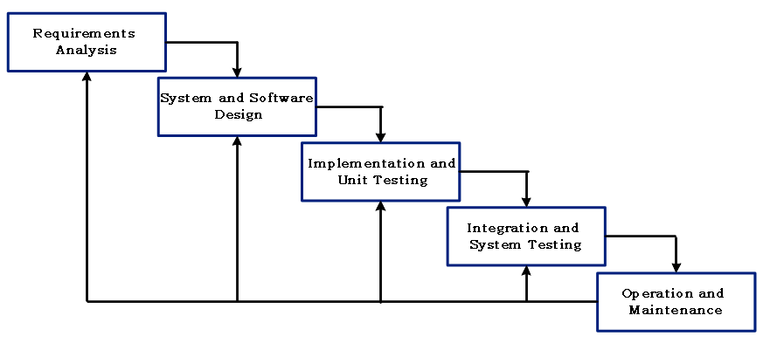The researchers decided to use the modified waterfall software process model as the conceptual model. The process model seemed fits to the project of the researchers due to its flexibility. It enables the phases to overlap when needed. The five activities or phases involved in the modified waterfall method are as follows:

**Figure 2. Software Process Model**

**Requirements Definition**- in this phase, the researchers are making plans for creating E-bayoy: Room Accommodation Portal gathering through an interview and actual observation.

**System and Software Design-** The proponent will design for graphical user interface and the database needed for developing the application after analysing the system needs and user requirements.

**Implementation and Unit Testing**- In this phase, the researchers will start to code to create the proposed system. And for the unit testing all the panel member are involved to test all the functions.

**Integration and System Testing-** Units or programs will be combining and tested as a complete system to ensure that the user requirement and software requirements have been met.

**Operation and Maintenance-** This phase errors possibly appear, and when it does not recovered earlier, improving, and enhancing according to the new problem and solutions during implementation. The researchers must assure that the deployed is well functional.

**Requirement Specification**

**User Specification**

* Administrator Module has all the privilege of the system. The admin can manage the clients and homeowners’ information.
* Homeowners are able to view their account where they can manage their business.
* Clients must be connected to the internet to create account and log in to view web content.

**Functional Requirements**

* The user has the authority in handling the system on his/her specified time
* Through this system the users can inquire for available room and have reservations in communicating homeowner
* The system can provide information about the available room.
* The system can create an advertisement and rate the boarding houses.

**Non-Functional Requirements**

**Operational Requirements**

* The system will be operated in android studio.
* The system will be able to use in the IOS, android, windows platform.
* The system will online.

**Performance Requirements**

* The system can be operated either in the computer or mobile phones through browser if it is connected to the internet.
* The system will be user-friendly, readable and easier to understand by the user.
* The system will be useful and hassle-free.

**Software and hardware requirements**

* Sublime text editor
* Android Studio
* Php
* 1 Laptop (core i5 or i7)
* 4GB RAM or higher

**Feasibility Issues**

The following feasibility analysis was created to test the proposed system. The highlights of the analysis are as follows:

**Economic Feasibility**

The application is Economically Feasible since it is free to use. The researchers decide to make the application free for all users, they don’t need to spend money to use the app.

**Technical Feasibility**

The researchers find some of the technical tools inside and outside of the Caraga region. If there would be a problem occurred in the application the user can send a message through email to the developer so the problem will be fixed.

**Operational Feasibility**

The researchers decide to make the application easy to find and download. The application is readable and user-friendly to make the user satisfied when using it.

**Schedule Feasibility**

The making of the project has a time schedule base on the potential time frames and the completion date whether the project on be met or not. The researchers aim to scope up the project to be complement on time without any delay.

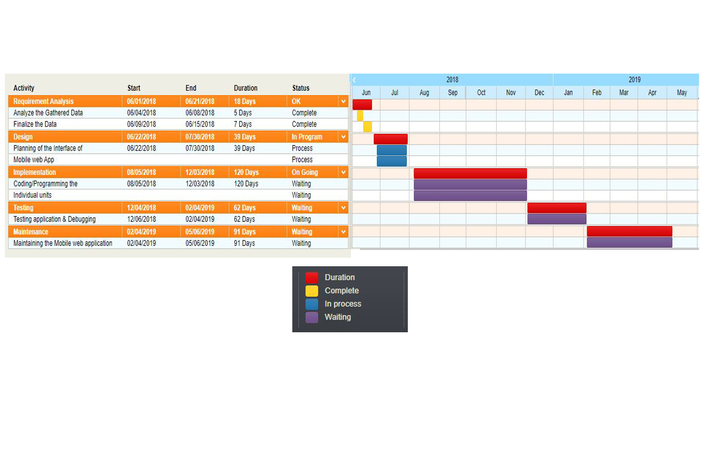**GANTT CHART**

**19**

**Project Cost**

In every capstone project has development cost and operational cost to be involved in order to create the application.

**Work Breakdown Structure**

This figure shows the division of the expenses in every phase of how the researchers develop the application.

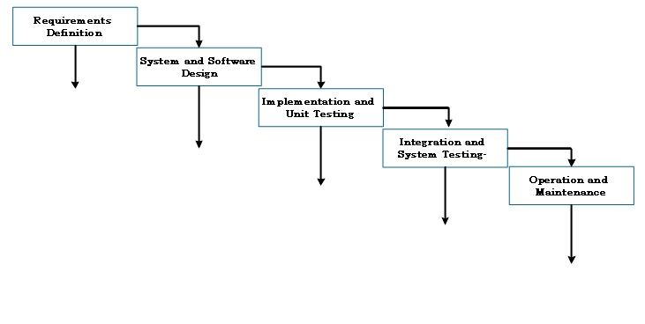

Internet 5%

Budget 1,500

Laptop 68%

Budget 20,000

Documentation 17%

Budget 5,000

Fare 3%

Budget 1,000

Domain 7%

Budget 1,000

Software Maintenance 43%

Budget 5,000

Hardware Maintenance 27%

Budget 3,000

Domain 7%

Budget 1,000

Electricity consumption 30%

Budget 3,500

**Table 1. Work breakdown Structure**

**Project Benefit Analysis**

The table 2 shows the estimated cost for the materials to be used in creating an application.

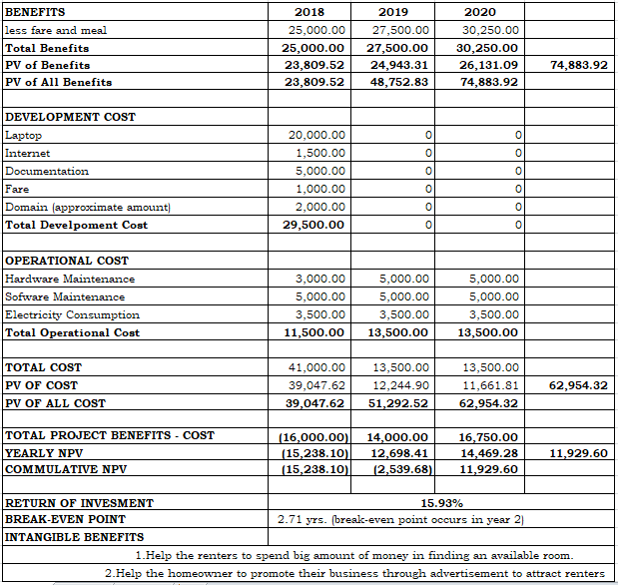

**Table 2. Project Cost Estimated**

**Risk Management**

The table 3 shown the possible problem encountered by researchers. It is also shown the effects and strategy if the researchers encounter the possible problem.

|  |  |  |  |  |  |  |
| --- | --- | --- | --- | --- | --- | --- |
| Risk | Level | Description | Potential  Indicators | Effects | Strategy | Status |
| Dropping of partner | High | The partner will drop from the class and stops going to school that may results to failure of doing tasks | The partner is frequently missing and failing to render his/her assignment task | The condition of this project is at risk and is unlikely to end | The partner will do will convince the partner to continue the project or maybe do his/her task | Avoided |
| System  Failure | High | A system failure can occur because of a hardware failure or a severe software issue, causing the system to freeze, reboots, or stop functioning altogether. | The team seldom to consult the OSA office that results to not meet their expectation to the system | The efforts of researchers will be useless. | Always consult the OSA office what they want to have in the system to meet their software requirements | Avoided |
| Financial | High | Estimated expenses should be made clear with the OSA Office | Cost can be incurred in the manufacturing of the software. | Results financial crisis during multiple stages of the project | The developer needs a buffer amount as it would decrease financial crisis | Avoided |

**Table 3. Risk Management**

**Implementation Plan**

The system to be implemented is following arrangements of steps. All the must be connected to the internet to view the content of the application, the client allows to communicate the homeowners for inquiry and for the reservations where they can view rating and feedbacks to choose their preferable boarding house.

Homeowner can communicate to the admin to ask for advertisement of their business and for some reasons. The admin can communicate only in the Homeowner who is registered in the mobile web application.

**Deployment Diagram**

The figure 5 shows the visualization of the study on how the researchers ought to deploy the application in the community. The interaction between the users and devices to be used are also reflected in the figure.

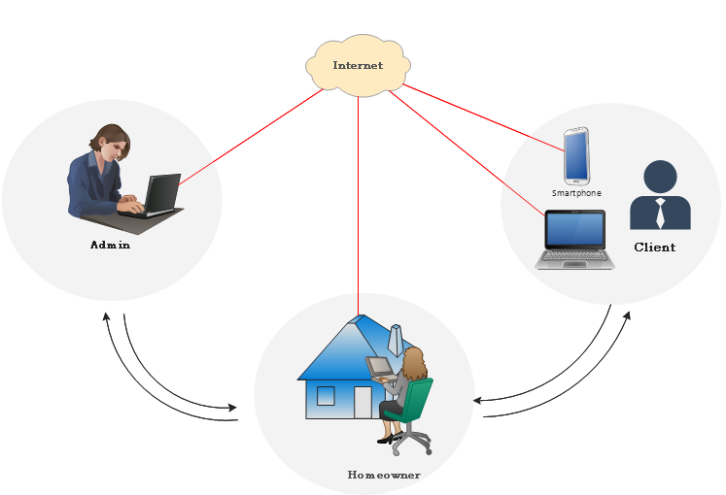

**Figure 5. Deployment Diagram**

**REFERENCES**

Babawale Akin Adeyemi, Mapping the Location Pattern of Hotels in Akure,

Ondo State. IORS Journal of Humanaities and Social Sciences (IOSR_JHSS) Volume 14, Issue 3 (Jul. – Aug 2013), PP 95-99 E-ISSN: 2279-0837, p-ISSN: 2279-0845. [www.Iosrjournal.org](http://www.Iosrjournal.org), Ondo, Nigeria. Retrieve from <http://www.academia.edu/download/32109817/Q01439599.pdf> on June 26, 2018.

Daniel Guettentag (2015) Airbnb: Disrupted innovation and the rise of an

informal tourism accommodation sector, current issue in tourism. Retrieve https:// [www.tanfonline.com/doi/abs/10.1080/13683500.2013.827159 on June 18](http://www.tanfonline.com/doi/abs/10.1080/13683500.2013.827159%20on%20June%2018), 2018.

Flórián Ákos Szabó, Web-Based Device Reservation System For Jyvsectec,

May 2014. Retrieve from <https://www.theseus.fi/bitstream/handle/10024/75539/BSC-Thesis-Florian_Akos_Szabo-2014.pdf?sequence=1> on July 20 2018.

Glenda A. Delizo and Mischelle A. Esguerra, Online Hotel Reservation and

Management System for the college of internaltional tourism and hospitability management (CITHM) July 25,2013 vol. 10 – no.1 editor at cirworld.com, Batangas City, Philippines. Retrieve from http://bspi.gov.bd/digital_content/329-345-1-PB.pdf on June 25, 2018.

Consignado, M. S., Velasco, M. A., Sanvictores, A. A., Jain, A.M. &F. F.

(2017). HAYBOL: An android-based apartment locator application. International Journal of Computing Sciences Research, 1(2), 1-9. doi:10.25147/ijcsr.2017.001.1.06, Laguna State Polytechnic University, Retrieve from <https://stepacademic.net/ijcsr/article/view/21> on June 26, 2018

[Meldrick P. Abella](https://ieeexplore.ieee.org/search/searchresult.jsp?searchWithin=%22Authors%22:.QT.Meldrick%20P.%20Abella.QT.&newsearch=true), Lander M. Pecdasen , Gideon Gerald R. Fajardo,

Layka G. Pascual , [Marilou N. Jamis](https://ieeexplore.ieee.org/search/searchresult.jsp?searchWithin=%22Authors%22:.QT.Marilou%20N.%20Jamis.QT.&newsearch=true), Board me app: A mobile application for finding boarding houses in university belt 2017, Sampaloc, Manila. Retrieve from <https://ieeexplore.ieee.org/abstract/document/8227973/> on July 8, 2018.

Reynold G.Bustillo and Benedicto G.Batistis, Boarding House Locator And

Student Monitoring System In Naval, Biliran Province, pilippines 2016, Biliran Province, 6560 Philippines. Retrieve from http://citeseerx.ist.psu.edu/viewdoc/download?doi=10.1.1.391.5751&rep=rep1&type=pdf on June 25, 2018.

RUEL A. BRILLIANTES, NELIA B. AGA,The Living Conditions of University

Students in Boarding Houses and Dormitories in Davao City, Philippines vol. 1 January 2012, Holy Cross of Davao College, Retrieved from http://www.academia.edu/download/34392005/5_RUEL-A.-BRILLIANTES.pdf on June 19 2018.

Sonya Manalo *et al,*Development and evaluation of mobile application for

room rental information with chat and push notification 2016, Bandung, Indonesia. Retrieve from <https://ieeexplore.ieee.org/document/7930293/on> June 25, 2018.

Xiaoqi Li, A literature review on value stream mapping with a case study

of applying value stream mapping on research process Copyright 2014, Texas A & M University. Retrieve from <https://oaktrust.library.tamu.edu/handle/1969.1/152791> on June 19, 2018.

P. S. Bangare1, P.N. Gandhi2, S.B. Diwate3, R.S. Gujar4, S. L. Bangare5,

The Campus Navigator: An Android Mobile Application, International Journal of Advanced Research in Computer and Communication Engineering Vol. 3, Issue 3, March 2014, Sinhgad Academy of Engineering, Pune, India. Retrieve from <https://scholar.google.com.ph/citations?user=MGFY18UAAAAJ&hl=en&oi=sra> on July 7, 2018.

**APPENDICES**

 **Curriculum Vitae**

**PERSONAL BACKGROUND**

Name : Jervel Bataluna Tamayo

Nickname : “din”

Address : Purok 14, Poblacion, Prosperidad Agusan del Sur

E-Address : jtams178@gmail.com

Birth of Date : March 8, 1993

Birth of place : San Quain, Prosperidad Agusan del Sur

Status : Single

Father : Jessie N. Tamayo Sr.

Mother : Julieta B. Tamayo

Motto : Do more of what makes you happy

Educational Background

Elementary : East Prosperidad Elementary School

Secondary : Prosperidad National High School

 **Curriculum Vitae**

**PERSONAL BACKGROUND**

Name : Glycil Mae Budias Manlapaz

Nickname : “Teng”

Address : Purok 1, Coalicion, San Luis Agusan Del Sur

E-Address : Glycil13@gmail.com

Birth of date : May 13, 1997

Birth of Place : Coalicion San Luis Agusan Del Sur

Status : Single

Father : Elvis O. Manlapaz

Mother : Victorina B. Manlapaz

Motto : I will and I can never I would give up if I could do it

Educational Background

Elementary : Delton View College

Secondary : Zillovia National High School